**Socket-** It is one endpoint of a two-way communication link b/w two programs running on the network.

* Socket system provides bidirectional **FIFO** communication over the network.
* Each socket has a specific address(composed of port number and IP)
* A socket is uniquely identified by-

1. IP
2. End to End protocol
3. Port number

**Types of (TCP/IP) Sockets –**

* Datagram socket (UDP)- connection less and data not in order
* Stream socket (TCP)- Reliable byte- stream service and data in order(send/received)

**Port Numbers-** They have decimal value ranging 0-65535.

#further grouping-

1. 0 – 1023 (Well Known Ports)-

These are allocated to server services with IANA (Internet Assigned Number Authority)

Eg- Web server normally used port 80

1. 1024 – 49151(Registered ports)-

Can be registered for services with IANA.

These are semi reserved

User written program should not use these ports.

1. 49152 – 65535(Ephemeral ports)-

These are used by client programs.

Eg- When web browser connects to a webserver, the browser allocates itself a port in this range.

**# Server – Client Model -**

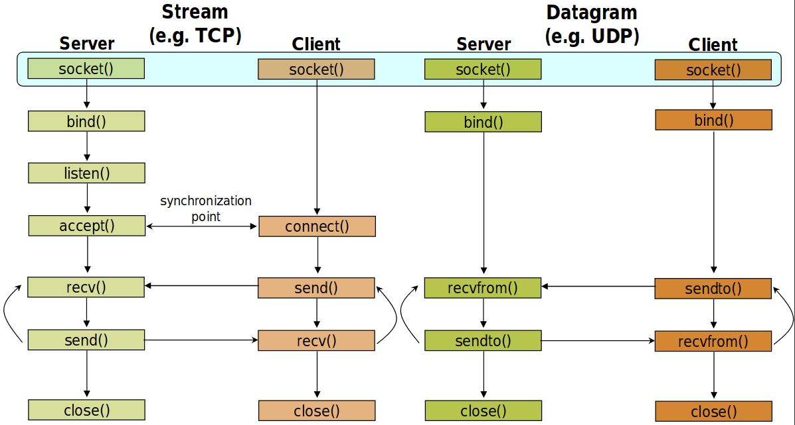

Some basics-

* **Socket()** – Create a socket.
* **Bind()** – Assign address to socket

(It’s a socket identification like telephone number to a contact)

* **Listen()-** Ready to receive connection
* **Connect()-** Ready to act as a sender(client connect with server using this)
* **Accept()-** Server gets a socket for an incoming client connection.
* **File Descriptor** – A file descriptor is a number uniquely identifies an open file in a computer’s operating system. It describes a data resource and how that resource may be accessed.

(Usually It’s 0 – successful, -1 – failure)

**About various functions and statement used in program-**

* **htons()-** stands for host to network short.

Used to provide the port number because in

// object.sin_port = 54000 – we can’t do that because of endianness. So, we use this function.

* **INADDR_ANY -** This allowed your program to work without knowing the IP address of the machine it was running on.  When receiving, a socket bound to this address receives packets from *all* interfaces. When sending, a socket bound with INADDR_ANY binds to the default IP address, which is that of the lowest-numbered interface.
* **inet_aton() -** returns non-zero if the address is a valid one, and it returns zero if the address is invalid.